

# CS 305 Project Two

**Practices for Secure Software Report**

Table of Contents

Document Revision History 3

Client 3

Instructions 3

Developer 4

1. Algorithm Cipher 4

2. Certificate Generation 4

3. Deploy Cipher 4

4. Secure Communications 4

5. Secondary Testing 4

6. Functional Testing 5

7. Summary 5

## Document Revision History

| **Version** | **Date** | **Author** | **Comments** |
| --- | --- | --- | --- |
| **1.0** | **[Date]** | **[Your Name]** |  |

## Client



## Instructions

Deliver this completed Practices for Secure Software Report documenting your process for writing secure communications and refactoring code that complies with software security testing protocols.

Respond to the steps outlined below and replace the bracketed text with your findings in your own words. If you choose to include images or supporting materials, be sure to insert them throughout.

## Developer

Sergio Udave

## 1. Algorithm Cipher

Determine an appropriate encryption algorithm cipher to deploy given the security vulnerabilities, justifying your reasoning. Be sure to address the following:

* Provide a brief, high-level overview of the encryption algorithm cipher.
* Discuss the hash functions and bit levels of the cipher.
* Explain the use of random numbers, symmetric vs non-symmetric keys, and so on.
* Describe the history and current state of encryption algorithms.

I chose the SHA256 (Secure Hash Algorithm) cipher for this project. It is a 256-bit cipher, that is irreversible by design. It was developed in 2001, in response to SHA1 becoming less reliable as it was prone to brute force attacks. This cipher is still in use today due to its low possibility of collisions and its security. The SHA256 plain text is sent to a digest, which handles multiple iterations of hashing, which then produces a seemingly random output that holds no significant value to an attacker. An asymmetric key means that there is a public key available to everyone for data to be encrypted, however a private key exists that enables the decryption of the data. Symmetric means that there is one key for both functions (encryption and decryption).

## 2. Certificate Generation

Generate appropriate self-signed certificates using the Java Keytool, which is used through the command line.

* To demonstrate that the keys were effectively generated, export your certificates (CER file) and submit a screenshot of the CER file below.

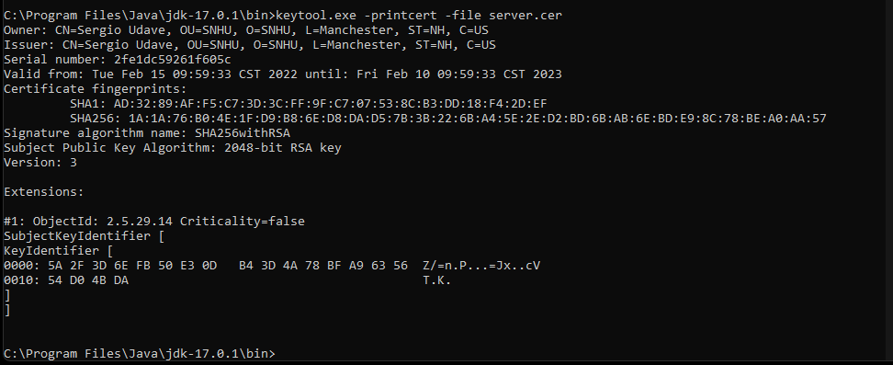

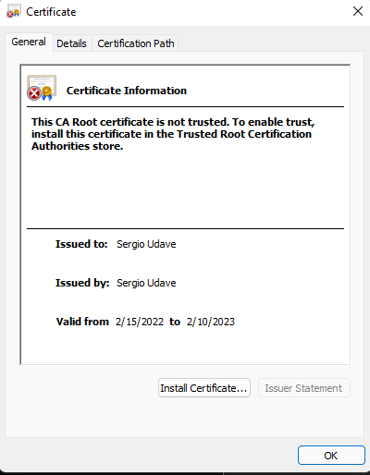

## 3. Deploy Cipher

Refactor the code and use security libraries to deploy and implement the encryption algorithm cipher to the software application. Verify this additional functionality with a checksum.

* 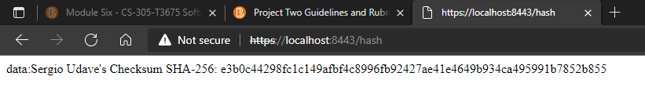Insert a screenshot below of the checksum verification. The screenshot must show your name and a unique data string that has been created.

## 4. Secure Communications

Refactor the code to convert HTTP to the HTTPS protocol. Compile and run the refactored code to verify secure communication by typing **https://localhost:8443/hash** in a new browser window to demonstrate that the secure communication works successfully.

* Insert a screenshot below of the web browser that shows a secure webpage.

## 5. Secondary Testing

Complete a secondary static testing of the refactored code using the dependency check tool to ensure code complies with software security enhancements. You only need to focus on the code you have added as part of the refactoring. Complete the dependency check and review the output to ensure you did not introduce additional security vulnerabilities.

* Include the following below:
  + A screenshot of the refactored code executed without errors
  + A screenshot of the dependency check report

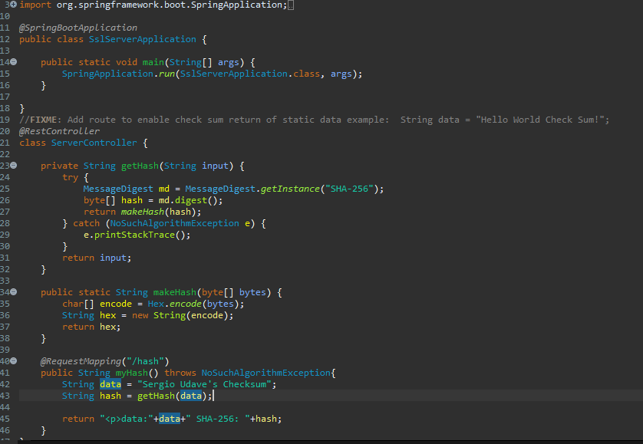

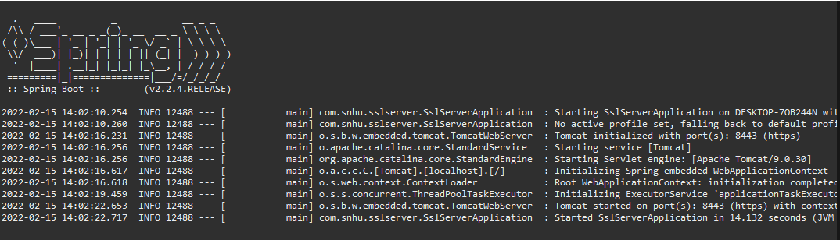

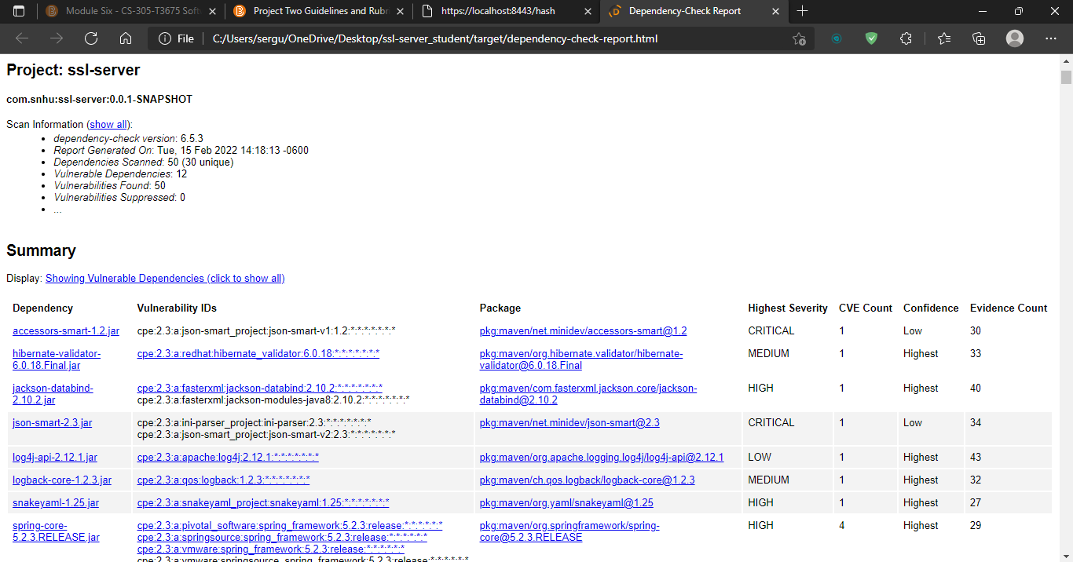

## 6. Functional Testing

Identify syntactical, logical, and security vulnerabilities for the software application by manually reviewing code.

* Complete this functional testing and include a screenshot below of the refactored code executed without errors.

## 7. Summary

Discuss how the code has been refactored and how it complies with security testing protocols. Be sure to address the following:

* Refer to the Vulnerability Assessment Process Flow Diagram and highlight the areas of security that you addressed by refactoring the code.
* Discuss your process for adding layers of security to the software application and the value that security adds to the company’s overall wellbeing.
* Point out best practices for maintaining the current security of the software application to your customer.

Incorporating the SHA-256 algorithm cipher allowed us to address cryptography by ensuring that a piece of input can be encrypted. As mentioned in the beginning of the paper, it contains the lowest probability of a collision and is still used today because of how robust it is. There is also error handling incorporated within the code to throw exceptions. It would be prudent to keep periodic checks on the dependencies to see if any vulnerabilities are found and if any updates come out that would improve the security of the application.